- Nginx installed, started and status: 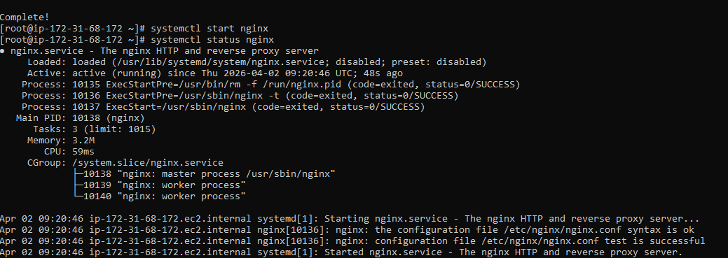
switched the port for Nginx to 81 number
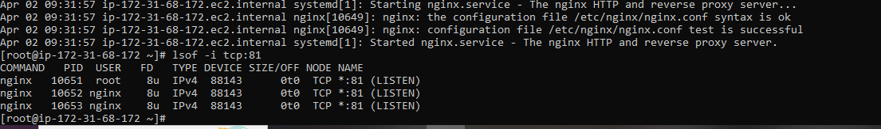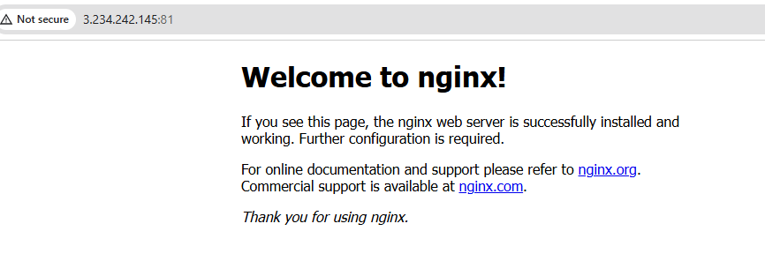

- Deployed a sample index.html file on nginx.

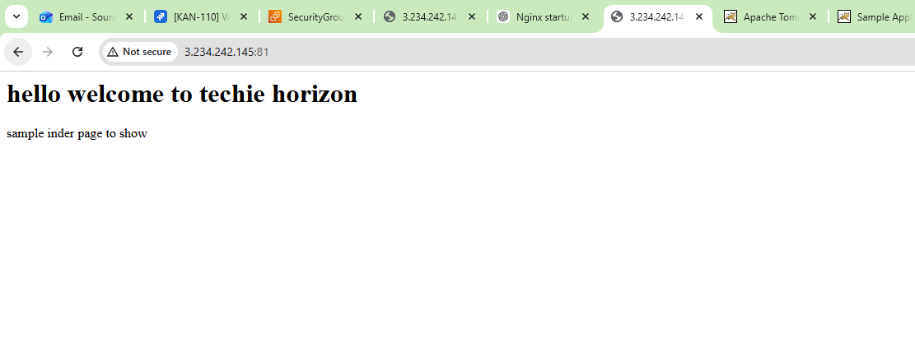

- Httpd {apache} installed, started and status:
switched the port for Httpd to 82 number: 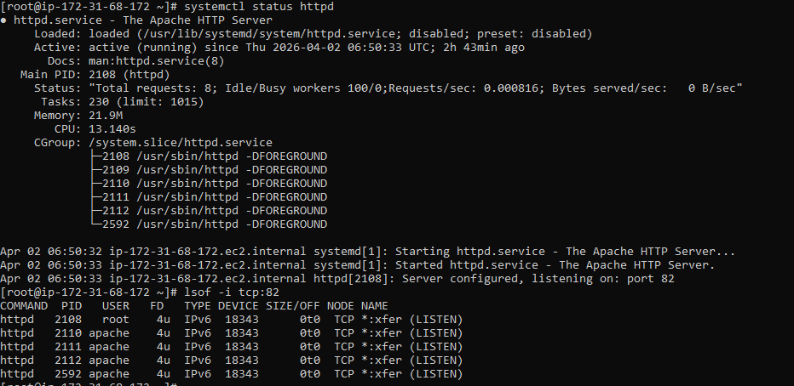
- Deployed a sample index.html file on nginx.


5. Installed Apache tomcat and changed the port to 8082 and uploaded the sample file as well.
6. Deploy a sample app on webapps
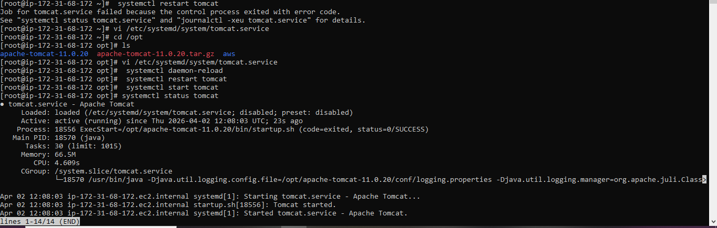
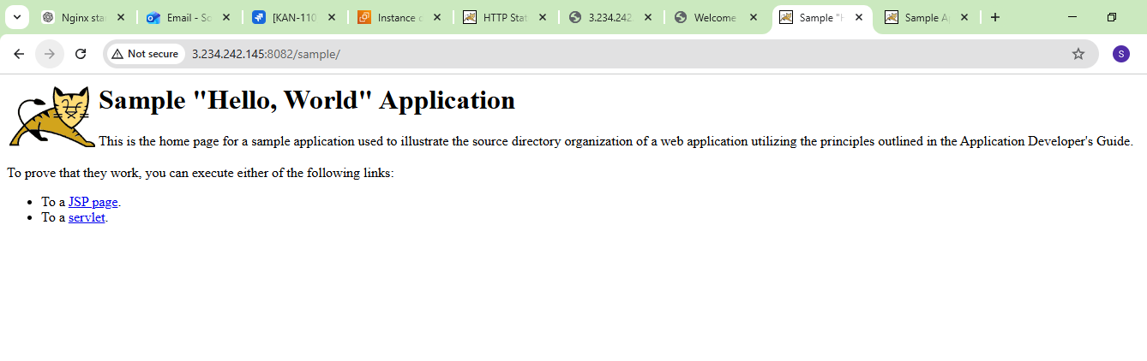
8. Configured HA Proxy server
server -1 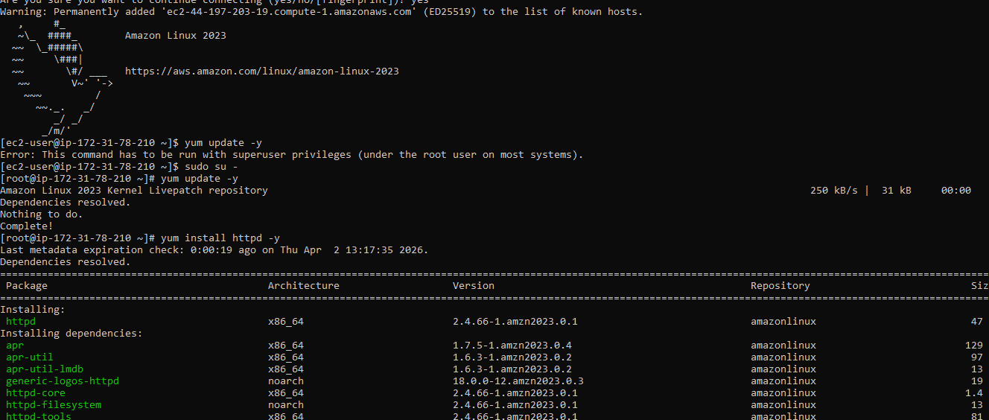
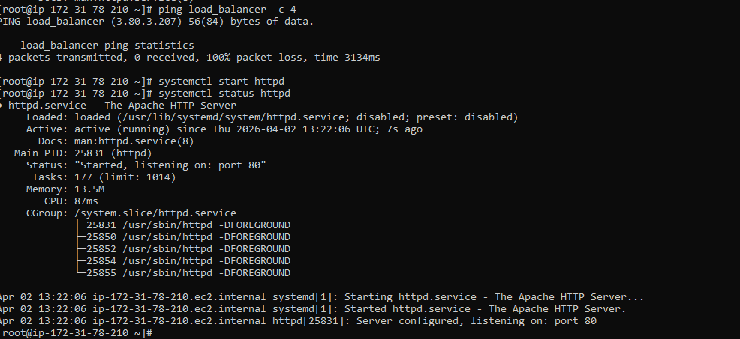
server2
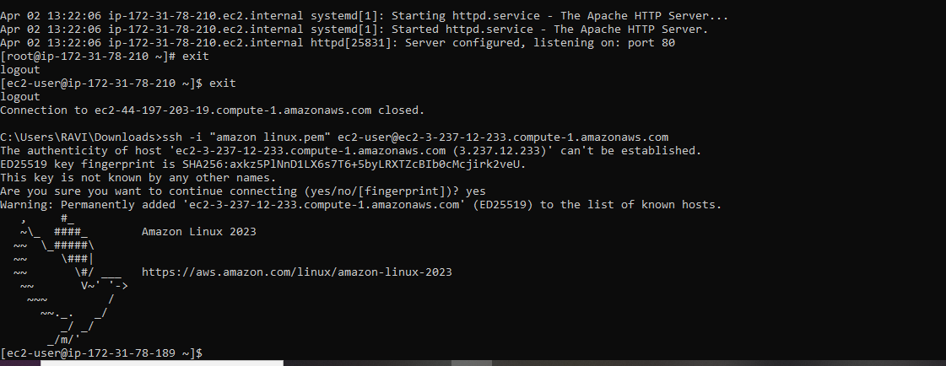
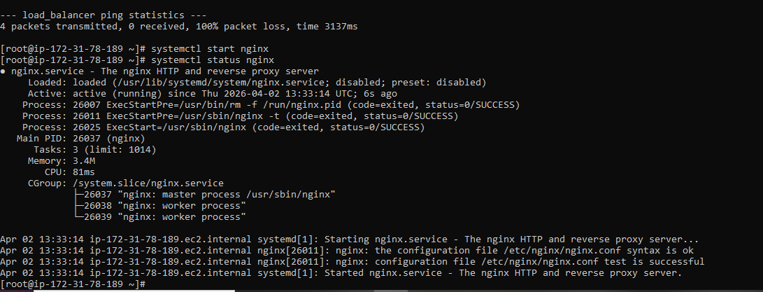
Server -3 